TAVERNERS

News & Review

Issue 253 – January 2010 - e-version 2



Club Sponsors: Fire and Ice

Website: www.tavernersfc.org.uk

TAVERNERS FOOTBALL CLUB

Established 1967

Members of the Ipswich Sunday Morning Football League since 1972
(Members of the Gippeswyk Sunday League 1967 - 1972)

Members of the Saul Charity Cup

Affiliated to the Suffolk County Football Association : No. GS100083

Colours:
1st team: White shirts, white shorts, black socks
2nd team: Yellow shirts, navy blue shorts, red socks

Home ground: Greshams Sports Club, Tuddenham Rd, Ipswich

Club Committee:

Chairman: | Pat Elvin | Tel: 748206
Vice Chairman | Bill Fleming | Tel: 742713
Secretary/1st team manager: | Bob Bullamore | Tel: 729586
Treasurer: | Gary Pilkington | Tel: 01394 386686
2nd team manager | Trevor Hollinsworth | Tel: 07802176434
Officers | James Bullamore | Tel: 07917185487
 | Bevan Burgess | Tel: 612693
 | Daren Stevens | Tel: 07979851887
 | Tom Brooks | Tel: 740868
 | Duncan Southgate | Tel: 07834614677

Club honours:

Taverners
News & Review

Issue no. 253 – 15 January 2010

Looking back with the Tavs
….from 5 to 40 years

5 years ago (November 2004)....The first team produced a tremendous fight-back to overcome two-goal Bourne Vale lead and finally win 3-2 in the Sunday Cup. Duncan Southgate 2 and Trevor Hollinsworth scored the Taverners goals.

We followed this up with a 2-1 win over Kesgrave Athletic in the League Senior Cup. Once again, a come-back was necessary after Kesgrave scored in the first half. We equalised through Trevor Hollinsworth and then, as reported in the ‘Taverners News & Review’ of the day..........
“Trevor Hollinsworth’s deep cross led to a goalmouth scrimmage and Paul Strutt (pictured below) latched onto the loose ball to drive it high into the net.”

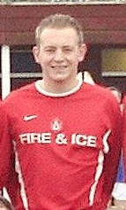
...And we had to fight back to win the following week too! This time Kelsale SC held a 3-1 lead before goals from Paul Strutt (pictured on right), Trevor Hollinsworth and Bevan Burgess secured a 4-3 Taverners win. Trevor had scored our first goal.

The first team swept Bourne Vale reserves away
6-0 with goals from James Bullamore, James Rice, Paul Strutt, Bevan Burgess, Duncan Southgate and Daren Stevens.

The reserves led twice against Kings Head (through Vaughn Gledhill and Matt Davis) only for our opponents to equalise both times and then go ahead themselves. Thankfully, Mike Ray grabbed a late leveller for a 3-3 draw.

The Tavs were delighted to beat Bourne Vale reserves – to whom we had lost the last two reserve Cup Finals – by 2-0 with a tremendous display. Vaughn Gledhill and Kevin Reilly scored the goals.

However, we were then beaten 4-2 by Rushmere CFC (scorers: Vaughn Gledhill and Ray Sherman) and the month ended disappointingly for the reserves with a 3-1 home defeat at the hands of Hadleigh Otto Campenelli. Ray Sherman scored the Taverners goal.

10 years ago (November 1999)....The first team were in disappointing form at home to Ipswich police and were beaten 3-0 but bounced back with a 5-1 win away to Blakenham Chequers.

Danny Marsh scored a hat-trick and our other scorers were Gary Cunningham and Andy Bown.

We then entertained Trojans and drew 1-1; Trevor Hollinsworth scored the Taverners goal.

The reserves gave a fine display away to Occold (at Bedfield) and won 3-0 with goals from Danny Marsh, Andy Bown and Gary Pilkington (back after a five-week break through injury).

We gave a reasonable display against league leaders Holbrook Rovers but were beaten 3-1; Ray Sherman scored the Tavs goal.

The Tavs made progress in the League Reserve Cup with a 4-3 win over Pauls reserves (after extra time). Tavs led 2-1 as the 90 minutes drew to a close (goals from Trevor Hedges and Mike Ray) but Pauls equalised and then went ahead 3-2 in extra time.

However, Ray Sherman outpaced the Pauls defence to level at 3-3 and then Pilky forced home the winner as a penalty shoot-out looked on the cards.

Scott Bennett had made several good saves while Julien Holmes (pictured below) made one double-clearance on the goal-line.

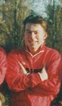
15 years ago (November 1994).....The first team began the month with a 2-1 defeat at home to Manor Club in the Sunday Cup. Ian May gave the Tavs a first half lead but we lost out to headed goals in each half.

A thrilling Senior Cup tie away to Hadleigh Town followed. Hadleigh took a two goal lead but Trevor Hollinsworth reduced the arrears.

Two crosses from Mike Cura – making his debut on his return to the club – gave Trevor the chance to bury two headers for a 3-2 lead (and complete his hat-trick). Hadleigh levelled at 3-3 but Paul Oakshott grabbed a last-minute winner for Taverners.

We were then beaten 4-1 at home by Port of Felixstowe, a score that flattered our opponents overall. Trevor Hollinsworth scored the Tavs goal.

The Tavs were then blasted aside 6-0 by Heathfield at home to record the 1st team’s worst defeat since the 1983/84 season.

We bounced back to beat Norbridge 5-2 at Cranes through goals from Trevor Hollinsworth (pictured below), Andy Glover, Kevin Oxborrow – an outstanding effort - Andy Spivey (penalty) and Paul Oakshott.

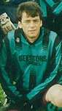
The reserves began November with a 4-3 defeat at the hands of Walberswick United, Neil Bennett (penalty) and Gary Cunningham 2 scoring the Tavs goals.

We recovered to beat Bourne Park Rangers away 6-5.

The result was in doubt until the final whistle and the Tavs goals were scored by Mike Ray 2, Shane Murrell, Daren Stevens, Mark ‘Bubble’ Smith and Gary Cunningham.

A 4-1 win over Eastern Electricity in the Sunday Shield followed, mike Ray and Gary Cunningham both scoring twice.

20 years ago (November 1989)...The first team began the month with a home game against Felixstowe Spartans and, in keeping with so many encounters between the two sides, this was a thrilling battle.

Spartans led for a long time but Taverners fought back to win with two goals from Andy Glover in the last five minutes, the winner coming from the last kick of the game.

We then beat Kirton United 2-0 with our best performance of the season; Gary Cunningham and Neil Bennett scored the Tavs goals.

The month ended with a goalless draw against RSSC Dales at Sidegate Avenue. The nearest the Tavs came to scoring was a disallowed effort by Andy Spivey.

The reserves bounced back from their defeat by Ipswich Postals reserves to beat Holbrook Rovers by 4-1, although only two late goals from Simon Finch gave the scoreline a one-sided look. Our earlier goals were scored by Bevan Burgess (pictured below), both dispatched in fine style after strong runs down the left.

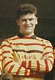
A penalty from Glen Parker gave the reserves the advantage at home to Italia but the visitors equalised from the spot and went on to score a late winner.

We then visited Blakenham Chequers and were far from flattered by the 1-4 scoreline. Blakenham led 2-0 only for the Tavs pull a goal back through John Simpson.

However, Taffy Goulding was unlucky from the penalty spot at a vital point and Blakenham went on to score two late goals.
We had no luck at all in our final game of the month against Ipswich Hospitals and were beaten 2-1; Shaun Watson scored the Taverners goal.

25 years ago (November 1984)....The first team visited Division 4 side Ambassadors on our old Bourne Park ‘B’ pitch in a League Senior Cup 2nd round tie and we took the lead through a superb angled volley from Gary Cunningham (pictured below), his first goal for the senior side. Gary put us further ahead before Ambassadors reduced the arrears with a headed goal.

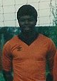
A foul on Steve Nunn late in the match enabled Glen Parker to net the resulting penalty and round off the scoring at 3-1.

We then beat Old Times in a Sunday Cup tie at Gainsborough Sports Centre by 4-2 with goals from Steve Nunn, Terry Pilbro, Pat Elvin and Glen Parker.

A league game against Crane Sports ended 3-0 to the Tavs via goals from Trevor Hedges and Terry Pilbro 2. Both Taverners and Ian Smillie’s Northam Celtic had been eagerly awaiting their League Cup tie and a classic encounter followed, with a final scoreline of 3-3 after extra time. Trevor Hedges 2 and a Glen Parker penalty scored for the Tavs.

The reserves began November with a most disappointing 4-3 defeat against Ipswich Rangers, one of the opposition’s goals being a freak effort scored by their goalkeeper!

Our goals came from Ian Scott and Elwyn Goulding 2 (one penalty). We gave an improved display to beat Fisons reserves 3-1. Elwyn Goulding 2 and Andy Spivey scored for the Tavs, ‘Spiv’s’ goal being his first for the club.

A visit to Walton rec. saw the reserves face Felixstowe Trades and Labour and draw 1-1, our goal coming from a Neil Bennett chip, and we followed this with a titanic Reserve Cup tie against British Telecom reserves.

A penalty from Daren Stevens in the final moments of extra time brought the Tavs a thrilling 5-4 win, our earlier goals having come from an Ian Scott hat-trick and Daren himself.

30 years ago (November 1979)....the first team’s home match against Sutton United resulted in a
3-2 Tavs’ victory, Glen Parker netting the winner in the last minute. Our earlier goals had come from Glen and Paul Miller.

We then entertained the young Aquarius side in a KO Cup 3rd round tie and, with 20 minutes left, looked to be on the way out of the competition as Aquarius held a 2-0 lead.

However, Glen Parker grabbed a goal from a corner and then Paul Miller equalised with a header. Extra time brought no further score.

The following week we drew 0-0 with Holbrook Rovers, who had come to Bourne Park boasting a 100% record, but they had to rely on their goalkeeper and the woodwork to salvage a point.

We ended the month with a 5-1 win over Northam Celtic with goals from Paul Miller 2, Glen Parker, Clive Bloom and Chris Potter.

The reserves played Railway Tavern at Gippeswyk Park and ran out 7-1 winners, our scorers being Keith Newman, Terry Pilbro 2, Steve Baker 3 and Louis Newman.

The following week the Tavs began somewhat unsteadily against Rampant Horse at Nacton and fell behind in the first half.

We equalised through Terry Pilbro (pictured below) after the break and, although Rampant Horse regained the lead, Louis Newman scored a late leveller.

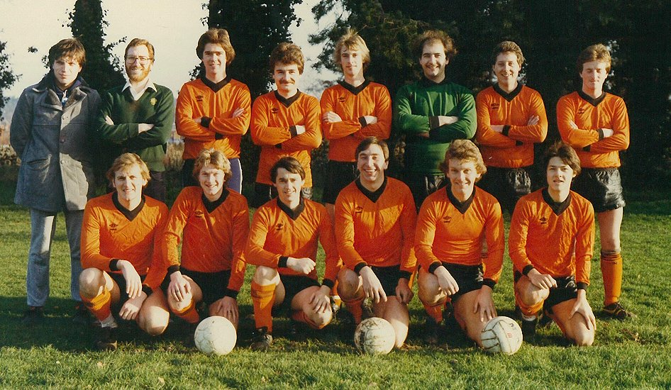
Aldridge Sports reserves were blasted out of the Reserve Cup, Taverners’ scorers in a 9-1 scoreline being Steve Baker 5, Brian Palmer 2, Bill Ormsby and Louis Newman.

Shortage of numbers placed the Tavs in a difficult position from the start against Lions Head at Raydon and we were soundly beaten 10-3.

Our goals came from Steve Baker 2 and Mitch Gallant.

35 years ago (November 1974)...Taverners visited John Player reserves in a Sunday Shield 1st round tie and gained a 2-1 victory after extra time with goals from John Davey and Don Muhs (pictured below).

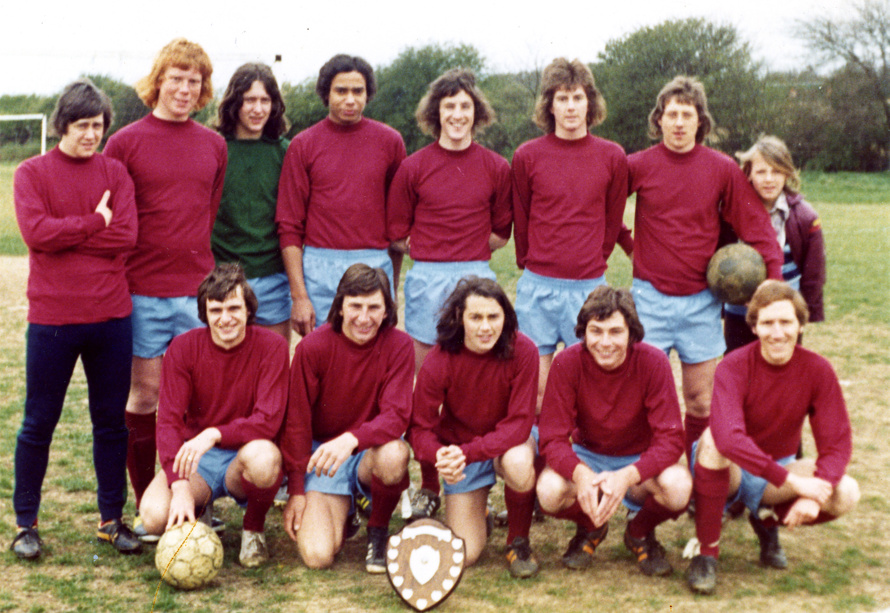
We then faced Thurleston YC reserves in the league and were beaten 4-2, Pat Elvin and Paul Miller scoring.

We bounced back a week later with a 3-2 win over Coastal Wanderers at Gippeswyk Park. Paul Miller, Mick Flude and an own goal scored for the Tavs.

Malga of Needham Market proved too strong in the League KO Cup a week later and were 6-1 winners. Pat Elvin scored our consolation goal.

40 years ago (November 1969)...we commenced the month with an unlucky 2-1 defeat away to Hollesley Sports – the borstal’s young team; John Steward scored the Taverners goal, while Dave Button (pictured below) was solid in our midfield.

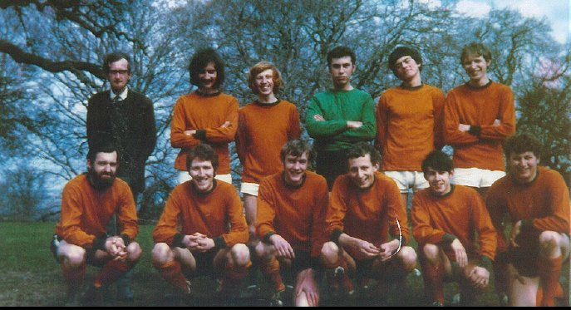
A week later, Campsea Ashe were our visitors at Woolverstone and we won an exciting tussle 3-2. Our scorers were Adrian Dickerson 2 and Martin Buck.

We then made an early exit from the Burton Cup, losing 5-2 to the ever-solid Blakenham– resplendent in a natty all-green strip – our goals coming from Mick Prentice and our lively winger, Adrian Dickerson.

First team focus

Battle in the mud.......Taverners 2, Ferry Boat 2

The 1st team’s home match against Ferry Boat saw
defences were very much in charge during a first half when much of the action was confined to the heavy midfield area.

Taverners benefited from the return of Ryan Horsfall, adding strength in his first full game after his year in Australia.

The fireworks were reserved for the second period and Ferry Boat were first to score with a well-taken goal immediately after the break.

Taverners came back well and a deft pass from Jason Riley gave Liam Claydon the chance to crash the ball home for the equaliser. Both teams had strong appeals for penalties turned down before Ferry Boat were awarded a spot-kick which they duly converted to restore their advantage.

A Ferry Boat side depleted by two dismissals were forced to defend as the Tavs pressed and Adam Beaney was unlucky to see a curling shot hit the post.

In trying to force the pace in their search for an equaliser, Taverners were nearly caught out on the break and Marty Smith was called upon to make two superb saves.

Inside the final minute of stoppage time, Jason Riley was fouled in the box and James Bullamore - making his return after injury - fired home the penalty to make the final score 2-2; a fair result.

Referee Andy Gray did well in a challenging game.
Team: M. Smith, A. Beaney, J. Bullamore,
A. Lambert, G. Cunningham (Sub: T. Vincent),
D. Southgate, T. Brooks, C. Keavey
(Sub: G. Pilkington), R. Horsfall, J. Riley, L. Claydon

Taverners FC
appearance & goalscoring
statistics 2009/10

1st team appearances |  | 2nd team appearances |  | 1st team goals
A Beaney | 11 | E Mongan | 11 | T Brooks | 7
T Brooks | 11 | J Brittain | 10 | J Riley | 5
G Cunningham | 11 | R Fisk | 9 | L Claydon | 3
L Riley | 10 | M Webb | 9 | J Bullamore | 2
J Riley | 10 | P Bowman | 8 | L Riley | 2
D Southgate | 10 | V Gledhill | 8 | D Southgate | 2
J Bullamore | 9 | J Holmes | 8 | A Beaney | 1
M Smith | 9 | T Atabaky | 7 | J Horsfall | 1
L Claydon | 8 | A Lambert | 7 | Total | 23
C Keavey | 8 | G Pilkington | 7
A Jacobs | 7 | M Aldred | 6 | 2nd team goals
A Lambert | 5 | B Burgess | 6
G Pilkington | 4 | T Hollinsworth | 6 | G Pilkington | 4
H Chard | 3 | A Smith | 6 | P Bowman | 2
B Burgess | 2 | P Strutt | 6 | J Brittain | 2
J Horsfall | 2 | J Valentine | 6 | A Lambert | 2
R Horsfall | 2 | S Burrows | 5 | P Strutt | 2
D Stevens | 2 | K Dawson | 5 | T Atabaky | 1
M Aldred | 1 | M Cura | 4 | H Chard | 1
T Atabaky | 1 | A Spivey | 4 | M Cura | 1
J Brittain | 1 | D Stevens | 3 | V Gledhill | 1
S Burrows | 1 | M Smith | 3 | T Hollinsworth | 1
L Farris | 1 | H Chard | 2 | E Mongan | 1
V Gledhill | 1 | T Brooks | 1 | D Stevens | 1
S Kidby | 1 | G Cunningham | 1
T Vincent | 1 | R Horsfall | 1
 |  | L Wiggins | 1
Possible | 11 | Possible | 11 | Total | 19

The Tavs in the last decade.....a quick look back
Everyone seems to be reflecting upon the ‘noughties’.....so the following are some thoughts on the period from the Taverners’ angle.......
The first team began the new millennium in a familiar situation - midway through a promotion season after having been relegated from the top division the previous year!
The series of yo-yoing between Division 1 (to become the Premier Division in 2002) and Division 2 continued for the following few years - at least it meant that there was rarely a dull moment for the Tavs as we either sought promotion or were fighting relegation.
The promotion season of 1999/2000 saw the Tavs play their first competitive game under floodlights (at Stowmarket Town FC against Debenham). On the playing front, Daren Stevens, Andy Spivey, Bevan Burgess and Andy Glover all made their 300th appearances for the Club while Matt Parker played his 200th game.
Our visit to Trojans clinched promotion but Trevor Hollinsworth was also able to celebrate his 100th goal for Taverners - scored in only 111 appearances!
Gary Cunningham also hit the headlines in overtaking Pat Elvin as the Club’s all-time top goalscorer with his 172nd goal for the Tavs.....Gary’s celebrations included pulling up his shirt to reveal an appropriate comment on his tee-shirt underneath!
The reserves were finding it tough playing first teams most weeks but spirits remained good and a highlight of season 2000/01 was an extraordinary 11-10 penalty shoot-out victory in a League Reserve Cup tie against Stow Pickerel reserves; Pat Elvin scored the vital spot-kick on a dramatic morning.
That season saw James Bullamore play his 200th game for the Club while Tim Howard reached 450 games.
We were honoured to be the only Sunday league club invited to the reception held for local football representatives by Mayor Don Edwards and at the League’s AGM we were revealed as runners-up in the Suffolk County FA’s ’Fairplay Awards’ for the season.
Season 2001/02 might have been described as one of ’mid-table endeavour’ at the time but it had its highlights: Andy Glover scored his 100th goal for the Club, our 35th season of playing competitive Sunday football was rounded off by a superb presentation/reunion night and then both our teams won the Fairplay Award for their respective divisions…..perhaps a unique achievement.
The reserve team’s goalkeeping position had been a problem for a while and six players took on the job during 2001/02 - Kevin Cole, Pat Elvin, Alan Goodyear, Simon Markwell, Daren Stevens and Graham Pateman.
On the managerial front, Gary Pilkington and Tom Walker each did a year’s stint in the reserve team’s ‘hot seat.’
Promotion back to the Premier Division was secured by a tremendous seven-game unbeaten run during a 2002/03 season which saw the 1st team also achieve a new Club scoring record in beating Ipswich Hospitals 12-0 - ironically while the manager was away in the USA!
Although the reserves only just avoided relegation, they again reached the final of the Reserve Cup - only to be beaten in the most heart-breaking fashion. Having battled so hard almost to the end of extra time, the softest penalty possible was conceded and opponents Bourne Vale reserves netted the winner from a rebound after Gary Cox had saved the spot-kick itself. Gary Cunningham was back in the manager’s role after Matt Parker had run the side for much of the season.
Duncan Southgate played his 200th game for the Club and Tim Howard reached 500 but they were topped by Pat Elvin making his 700th Taverners appearance.
The ‘downside of the yo-yo’ saw the first relegated to Division 1 in 2004 after a brave fight; our fate was decided by a defeat in our last game against Kesgrave Athletic after we had led at half-time. We had the consolation of winning the Divisional Fairplay award.
The reserves made another appearance in the Reserve Cup Final but, this time, were very much second-best, losing 3-0 to the holders Bourne Vale reserves.
More ‘milestones’ were achieved. Bevan Burgess, Daren Stevens and Gary Cunningham each made their 400th appearances for the Club while Gary made it a double by scoring his 200th goal for the Club.
The 2004/05 season began with a game between a current Tavs squad Xl and a ‘mature Xl’ to celebrate the achievements of Bevan Burgess, Gary Cunningham, Daren Stevens and Andy Spivey in playing their 400th games for the Club; Andy had made his 400th appearance in the season’s opening game.
It was tremendous that Pat Elvin (721 appearances), Tim Howard (530) and Trevor Hedges (414) also took part under the Ipswich Wanderers’ floodlights.
An exciting season ended with the first team grabbing the runners-up spot in Division 1 - so it was back to the Premier once more!
The early part of the season saw too many goals being conceded and we had to rely on some fight backs - notably from 3-0 down to beat Trimley Rangers 5-4, from two goals behind to beat Bourne Vale 3-2 (both in the Sunday Cup) and from 3-1 down to beat Kelsale SC 4-3 in a league game.
In addition to our league success, the first team reached the quarter final stage of both the County Sunday Cup and the League Senior Cup.
The 1st team’s 5-4 win away to Worlingworth saw Andy Spivey net a penaly. Nothing remarkable about this…….until you realise that this was Andy’s 27th successful spot-kick for Taverners!
Certainly a record for the Club and possibly a total unbeaten in local football?
Julien Holmes was appointed reserve team player-manager in 2004 and his first season in charge was one of mid-table consolidation. The early part of the season was a little unsteady but the Tavs finished with a run of seven games which only contained one defeat.
During the season, both Mike Cura and Trevor Hollinsworth notched up their 200th appearances for the Tavs.
The first team managed to hold onto Premier Division status in season 2005/06 as a result of a turn-round of fortunes from March onwards - after not managing any league wins at all before Christmas! The highlights were two away wins (one in the Senior Cup) over Belstead Arms.
The reserves just managed to escape relegation which, as often in the past, was enough to see them promoted - to Division 1.
The season saw Gary Pilkington play his 200th game for the Club while James Bullamore reached 300 appearances.
And we come to 2006/07 - the Club’s 40th season of competitive Sunday football. While we were delighted to have reached this significant milestone, it was clear from the beginning that neither of our teams would have an easy season.
In fact, it turned out to be one of the most difficult in the Club’s history and, unfortunately, both teams suffered relegation. It must be said that we were playing at the highest level in Sunday football - any mistakes or weaknesses are severely punished.
At least we battled on, the reserves maintaining their spirits despite some heavy defeats while the first team fought ‘the drop’ to the very end and picked up a number of good results in the new year including taking four points from Championship contenders Wickham Market and beating AFC Woodbridge and Kelsale Sports Club.
During the season, the Tavs broke new ground by becoming the first Sunday club to participate in the Saul Charity Cup. On the ‘milestone front’ Duncan Southgate collected a memento for playing his 300th game for the Club.
The year was rounded off by a superb Reunion and Presentation Night held at the Legends Bar at Portman Road.
As well as the normal annual awards ceremony, a selection of photographs covering the Club’s 40 year history were on display and tribute was paid to those present who had won ‘Player of the Year’ awards in previous years and those who had amassed impressive appearance totals - evidence of the loyalty which had been enabled Taverners to continue and thrive for 40 years.
The 2007/08 season produced thrilling games, lots of goals and some fine displays but the first team ended ‘so near and yet so far’ from promotion. Third place was not enough to reach the play-off. The team also had two good cup runs - reaching their first semi-final in the League Senior Cup - but missed out on a final appearance by the odd goal.
The reserves - under the new management of Trevor Hollingsworth - reached the semi-final of the Reserve Cup and managed to stave off relegation with a late flurry.
Jason Riley hit the headlines with 27 first team goals from 26 games - the best total for over 30 years - while Bevan Burgess and Daren Stevens each played their 500th game for the Club and Daren scored his 100th goal.
The club had a generally successful season in 2008/09, both teams finishing in third position in their respective divisions – the reserves’ climbing to that level through a flurry of good late results after a campaign fighting relegation!
Trevor Hollinsworth played his 300th match for the club while Gary Cunningham made it to 500. The recent achievements of Gary, Bevan Burgess and Daren Stevens in reaching five-centuries were celebrated in a special match under the Ipswich Wanderers FC lights. Frank Fleming had decided to step aside as club secretary – after 42 years service – and his efforts were also saluted in the presentation match; a special Taverners evening. Frank also received a presentation from the Ipswich Sunday Football League.
As well as momentoes, the ‘famous-four’ were presented with bound match programmes, including Warren Page’s superb colour section; Elvin King, as usual, did us proud with coverage in his Evening Star column.
The league structure meant that the reserves’ third position in RM Division 2 gave them automatic promotion to RM 1 but the first team had to wait until mid-August before a club-withdrawal in the Premier Division allowed them to step up.
As the noughties’ decade draws to a close, the first team have managed a promising position in the Premier while the reserve team have much to do to hold onto Division 1 status.
The 2009/10 season so far has seen Gary Pilkington reach his 300th appearance for the club; another fine achievement.
The opening years of the new century have seen stability - both our teams have continued to enjoy the superb facilities at Greshams Sports Club for games on Sundays and training has been maintained on a regular weekly basis at Copleston Sports Centre.
In fact, midweek training has been enjoyed by Taverners’ members uninterrupted since its introduction in 1972!
The club has continued to make Easter trips to Brussels for the Royal Brussels British FC tournament but with less frequency than before; it’s hoped that this will pick up again – perhaps starting in 2010?
The ‘noughties’ saw the re-introduction of the Club’s ‘Penalty Ace’ competition and the winners have been James Bullamore, Tom Blake and Tom Brooks.
Trevor Hollinsworth’s continuing valuable support maintained the Club’s smart image on the field of play and various kits have been worn: black & white, navy/sky quarters, ‘Chelsea’ all-blue, sky & white, red & white, ‘Roma’ maroon, yellow and navy and ‘Real Madrid’ all-white.
A major change has been the introduction of the club website – www.tavernersfc.org.uk – and we are so very grateful to Bevan Burgess for his work in establishing and designing it – and for his promptness and ingenuity in keeping it up-to-date and entertaining.
It should be noted that a full club history appears on the Tavs website, as above.
A further ‘move with the times’ is the publication of an ‘e-version’ Taverners News & Review and this has been well-received.

Bully’s new Tav-analysis
This issue: Jason Riley

Date of birth: 6 March 1983 Position: striker

Nickname: None

Previous Sunday club(s): The Rampant Horse

Saturday clubs: N/A

Best ground played at: Cambridge City

.....and the worst: Capel Plough
Most memorable game played in: Against Ascio last season when I scored two second-half goals to help turn a 2-0 deficit into a 3-2 Tavs win.

Favourite player: Steven Gerrard Favourite (pro) team: Liverpool

Hobbies/interests: Football, design, music, films

Favourite food/drink: Pasta / beer

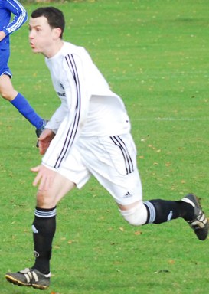
Favourite singer or band: Kanye West

Favourite newspaper or mag: Creative Review

Tavs’ statistics:
Appearances - 1st team 84, 2nd team 6
Goals - 1st team 52, 2nd team 4

More Looking back with the Tavs….from 5 to 40 years

5 years ago (December 2004)...The first team recovered from an AFC Woodbridge goal to win
3-2 with goals from Matt Parker, Daren Stevens and Trevor Hollinsworth. Trev’s winner was a fitting way for him to celebrate his 200th appearance for the Tavs.

We then qualified for the quarter finals of the Sunday Cup by beating the Horse & Groom (from Sudbury) by 4-0. Tom Parker, Duncan Southgate, Gary Pilkington and James Bullamore scored the goals while we were grateful to David Rice (pictured below) for a penalty save when we were only one goal up.

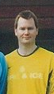
A week later, we were disappointed to lose 3-0 to Kelsale SC.

The reserves began the month by beating Orford Sports (away) 2-0 with goals from Scott Welton and Kevin Reilly. The Tavs News & Review of the day reported that ...”the true difference between the two teams was the appetite for the battle in the Taverners midfield with Scott Welton, Ashley Watson and Mike Cura all playing with grit and determination.”

The reserves surrendered a 2-0 lead against Rushmere CFC to finally lose 3-2 although they had missed enough chances before the break to have won easily. Gary Cunningham and Liam Claydon scored the Taverners goals.

10 years ago (December 1999).....Postponements meant that the first team’s only game was a 4-0 win over old rivals – now sadly defunct – Hintlesham United. Trevor Hollinsworth 2, Andy Bown and Gary Cunningham scored. Daren Stevens and Duncan Southgate both hit the bar but Taverners were grateful to Alan Goodyear for some fine saves throughout the match.

The reserves disappointed with a 3-2 home defeat at the hands of Stoke Athletic, particularly as we had twice fought back to equalise, only to let Stoke in for a headed winner a few minutes from time. Tom Foulk and Ray Sherman scored the Taverners goals.
A vital win for the reserves followed. SEH scored with their first attack but the Tavs fought back to equalise with a shot from Ray Sherman (pictured below) from the edge of the box and then Ray fired in the winner ten minutes from time. Simon Markwell had made some excellent saves.

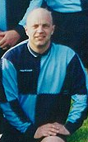
15 years ago (December 1994)...The first team were knocked out of the League Senior Cup 5-0 by Stowmarket Vandals but bounced back to a 7-0 win away to Ipswich Hospitals in a highly charged game.

The Tavs scorers were Trevor Hollinsworth 4, Mike Cura, Paul Oakshott and goalkeeper Mark Moore (penalty).

Another heavy defeat – 5-0 at home to Capel Plough – followed but, once again, the Tavs came back to win 2-1 away to Eastern Eagles. Trevor Hollinsworth scored both our goals.

The reserves began with a 6-2 win against Malton YCOB reserves and both Make Ray and Gary Cunningham registered hat-tricks for the Tavs. We followed this with a 10-0 win over Division 10 side BT ‘B’ in the Reserve Cup. Shane Murrell, Toby Cousins, Mark ‘Bubble’ Smith, Ian May, Mike Ray and Gary Cunningham 4 scored the goals.

Our tremendous Sunday Shield run continued with a 1-0 win at home to IPA reserves, Toby Cousins scoring. The reserves followed this with a 5-0 win over John Player reserves (away). Andy Glover 3, Eamon Mongan and Mike Ray scored the goals although the Tavs relied on goalkeeper Tony Thomas (pictured below) for several tremendous saves.

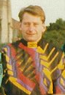
20 years ago (December 1989)...On a heavily mist-shrouded Cranes, the first team began the month with a home draw against Monks Eleigh.

Daren Stevens had the misfortune to head into his own goal to put Eleigh ahead but Taverners equalised in the second half through Simon Finch.

Conditions were very difficult when we visited Kirton United, a high cross-wind looking the likely winner as both teams found constructive football a problem.

However, things changed only minutes into the second half as Taverners grabbed two goals and the held on to win. Simon Finch and Neil Bennett were our scorers.

Andy Spivey (pictured below) ‘came a cropper’ in sustaining a nasty wrist injury while some will recall Steve Easter’s clash with a metal climbing frame as he fielded a ball which had gone a long way out of play; Steve was doing a sterling job as Tavs’ club linesman at the time.

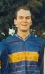
We had always found it difficult to get results against Dales over the years and this ‘jinx’ struck again as we were beaten 4-0 by RSSC Dales at Cranes to put a dent in our hopes of promotion from Division 3.

The reserves began with a tremendous performance away to top-of-the-table side Aldridges and emerged 3-0 winners.

Warren Page scored a great goal to give us the lead and our other goals came from Jamie Needham and Elwyn Goulding.

Unfortunately, we were hit by a player shortage for our visit to Harleys and were beaten by two clear goals.

A relegation clash against Capel Plough reserves followed and, after good work by goalkeeper Shane Chamberlain had kept a clean sheet for the Tavs, a goal three minutes from time from Daren Stevens saw the reserves home by 1-0.

25 years ago (December 1984)...Taverners’ first team faced old rivals Northam Celtic in a League Senior Cup 3rd round replay at Gainsborough Sports Centre and were beaten 3-2 in a thrilling game by a goal scored in extra time, the scores at 90 minutes being 2-2; Steve Nunn and Pat Elvin scored the Tavs goals.

We quickly returned to winning ways with a 5-0 victory over Rosary (from the Licensed Trades League) in a Sunday Cup tie, our goals coming from Pat Elvin 2, Steve Nunn, Gary Cunningham and Chris Lushington (pictured below).

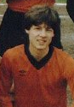
With ten minutes of our match against Finchley Athletic left to play, we were 2-0 up (via goals from Neil Bennett and Martyn O’Leary) but Finchley pulled a disputed goal back and then went on to score twice more to grab the points in a game played in a mudbath.

We were then beaten 4-1 by Stowmarket Athletic reserves (with Chris Lushington scoring) but we grabbed a point the following week when two goals from Pat Elvin saw us fight back from a 2-0 deficit against Felixstowe Dock Athletic at Trimley.

The reserves had the misfortune of facing the high-flying Hintlesham United twice in successive weeks and were beaten 7-2 and 8-1. Paul Smith 2 and Neil Bennett scored the Taverners goals.

Another defeat – although an unlucky one – followed as Stour Vale won an end-to-end encounter 5-4, the Taverners scorers being Daren Stevens, Paul Smith, Clive Bloom and an own goal.

We then visited Aldridges reserves at Chantry Park and were beaten 3-1, the Tavs scorer being Ian Scott.

30 years ago (December 1979)...The first eleven began with a 0-0 draw against Borough Engineers with goalkeeper Colin Dawson outstanding for the Tavs.

We were then blasted out of the League KO Cup by Aquarius, our scorers in a 6-2 reverse being Cecil Pittock – a great header- and Pat Elvin.

Another 6-2 defeat, this time at the hands of New Park Rangers Old Boys (Pat Elvin and Steve Baker scoring) was followed by a 4-1 victory over Queens at Bucklesham. Steve Baker 2 and Glen Parker 2 (both penalties) were the Tavs marksmen.

The reserve team were beaten 7-3 by West End reserves, our goals coming from Mick Flude 2 and Louis Newman, but bounced back to beat Somersham reserves 3-2 via a late fight-back and goals from Brian Palmer 2 (pictured below) and Bill Ormsby.

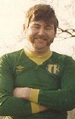
Armada reserves proved difficult opponents and they ran out 7-2 winners against the Tavs reserves.

Our scorers were Dave Piper and Keith Newman.

An unusual feature of the game was that three different referees were called upon to take charge, the third assuming control after only 20 minutes play!

35 years ago (December 1974)...We began the month with a home second round Sunday Shield tie against Kitchener Taverners reserves and threw away a 3-1 lead (built up through goals from Mick Flude 2 and Chris Sefton) to draw 3-3.

Sendings-off were not as common in those days but some unsavoury incidents throughout the match eventually led to a player from each side being dismissed.

A week later we were beaten 4-1 in the replay, Paul Miller scoring the Taverners goal and we were then defeated 2-1 by Rampant Horse, scorer Chris Sefton (pictured below) in a game littered with a number of controversial offside decisions against us.

‘Offside’ has always been a contentious issue!

We ended the month with a
5-2 defeat at the hands of the up-and-coming Magpies, Mick Flude and John Davey scoring the Taverners goals.

40 years ago (December 1968)...Blakenham followed their Burton Cup win over the Tavs the previous week by winning a Gippeswyk League encounter ....... and we had no better luck the following week in losing 4-1 to Mann Egerton. Ross Turtill scored for the Tavs.

A frosty and misty afternoon saw Taverners entertain Hollesley Sports at Woolverstone and we were beaten 4-2 in a closely fought game. The Tavs goals came from Ross Turtill and Mick Prentice.

The club was experiencing severe goalkeeping problems at the time and one of the Hollesley goals was an ‘og’ registered by club co-president John Steward, who watched in horror as his gently-struck back pass – which could be picked up by the keeper in those days – crept through our custodian’s legs and just over the line!

One of John’s team-mates that afternoon was left back Ralph Murray (pictured below) who had joined the Tavs at the beginning of the season.

December ended with a trip to Campsea Ashe. The pitch was in a completely waterlogged state but – in view of our journey and both teams’ keenness to play – the referee decided to go ahead.

We were soon to regret this decision as we were beaten 5-1. The Tavs goal came from Mick Prentice.

Belgium 2010 – is it on?

We have to make an early decision on whether we have enough support to organise an Easter trip this year. The broad format would be:

Good Friday (2 April): Drive from Crown Street to Dover for a ferry crossing to Calais. Arrive Brussels mid-afternoon. Evening free.

Saturday (3 April): Take part in Royal Brussels British FC’s annual tournament, lasting all day. Super facilities and bar open all day. Evening free.

Easter Sunday (4 April): Morning free. Drive to Belgian coast and, after a break, on to Calais for return ferry to Dover and then home to Ipswich.

Coach/ferry travel & a central-Brussels hotel stay would be included in the £200 cost, but we need a party of at least 19. Please text Bob (07810251177) or email him bob@bullamore.fsnet.co.uk to indicate your interest.

Taverners FC - Results - 2009/10
1st team |  | 2nd team
Belstead Arms (a) | 0-3 | Chantry Blues (h) | 0-1
Whitton Maypole S/Cup (h) | 1-8 | Bramford Cock (h) S/Shield | 1-0
J Riley |  | Pilkington
Ferry Boat (a) | 2-2 | Aldeburgh Associates (h) | 3-5
Southgate, Claydon |  | Cura, Pilkington 2
AFC Woodbridge (h) | 1-1 | Alderton (a) | 5-1
J Riley |  | Strutt, Mongan, Bowman, Stevens, Lambert
Hadleigh RBL (a) | 7-3 | Holbrook Swan (h) | 1-4
L Riley 2, Southgate, Claydon, J Horsfall, Brooks, Bullamore (pen.) |  | Gledhill
Whitton Maypole (h) Sen. Cup (lost on pens) | 3-3 | Felixstowe Dolphins (a) S/Shield | 4-1
Brooks 3 |  | Bowman, Atabaky, Brittain, Pilkington
Capel Plough (h) | 2-1 | Hadleigh Gold Star Athletic (a) | 1-7
J Riley, Brooks |  | Lambert (pen.)
Martlesham Old Boys (a) | 4-1 | Corton White Horse Seltic (a) S/Shield | 2-4
Beaney, J Riley 2, Brooks |  | Strutt, Hollinsworth
Martlesham Old Boys (h) | 1-0 | Trimley Rangers (a) | 1-8
Brooks |  | Chard
Kirton United (a) | 0-4 | Lions Head Athletic (h) | 1-1
 |  | Brittain
Ferry Boat (h) | 2-2 | Ferry Boat Sen. Cup (h) Sen. Cup | 0-6
Claydon, Bullamore (pen.)

Remaining fixtures
Jan | 24th | Ascio | h | E & D Athletic | a
 | 31st |  |  | Trimley Rangers | h
Feb | 7th | Belstead Arms | h
 | 14th | Whitton Maypole | h | Lion Head Athletic | a
 | 21st | Ascio | a | Alderton | h
 | 28th | Locomotive | h | Norbridge | a
Mar | 7th
 | 14th | Whitton Maypole | a | Margaret Catchpole | h
 | 21st |  |  | Fat Cat | h
 | 28th | Unicorn | h | Margaret Catchpole | a
Apr | 4th | Easter |  | Easter
 | 11th | Capel Plough | a | Easter
To be arranged:
1st team: Unicorn (a), Kirton United (h), Locomotive (a), AFC Woodbridge (a), Hadleigh RBL (h).
2nd team: Aldeburgh Associates (a), Fat Cat (a), Chantry Blues (a), Holbrook Swan (a), Hadleigh Gold Star Athletic (h), Norbridge (h).

The last word......

Predictable as it will be......we have to start by mentioning the weather!
It’s certainly been many years since we have seen our own fixtures – and those throughout both Saturday and Sunday football - so badly affected by the severe wintry conditions.

And the postponements over the last few weeks haven’t been in any doubt – at least the early decisions have avoided needless journeys and also the routine of putting together the kit, pumping up the balls, needlessly cutting-up the oranges and preparing thermos-flasks of delicious tea and coffee which then go to waste!
The icy conditions persisting on the Copleston Sports Centre all-weather surface have also meant that training sessions have been cancelled since mid-December.
Of course, it does mean that keeping in touch with club members has been difficult but, hopefully, the News & Review – combined with our website (for anyone new to us www.tavernersfc.org.uk) will help everyone keep up with developments. Our website now contains ‘archive News & Reviews’ beginning with the last issue.
This edition seems to have concentrated on ‘days gone by’ but, unfortunately, the weather has restricted the club to just one actual football match to report on since the last issue!
You might have noticed a different format for recording our results for the season so far, the scorers in each match also being shown. The list of fixtures still to be played reflects several re-arranged games, with more to be re-scheduled over the coming weeks.
The editor’s request (in the last issue) that those members and supporters who usually receive their copies of the newsletter through the post might like to provide an email address has been very productive; another rain-forest saved by the Tavs!

The club committee has already held one constructive and positive meeting this year. Improving our playing strengths is always high on the agenda and we are pleased to welcome new signings Dan Sheridan (a Taverner of only a few years back, of course) and Darren Cox to the club; we hope they enjoy their football with us.
Hopefully, the next edition of the News & Review will have a few weeks’ football action to report!

The last word......


Brickwork Ltd.
L
S
M

LSM Brickwork Limited
Brickwork & Building Contractors
Tel/Fax (01473) 215321
Lee Smith (07904) 384242 (24 hrs)

